Practical Task 06
CSC-369

Semester 7
Digital Image Processing

Task 1:
Using 8-Connectivity, write the code to label each object. Refer to the lecture notes for the algorithm. Do not use the built-in functions.
The code should display the equivalency table, and the final total number of objects found in the image.
Code:
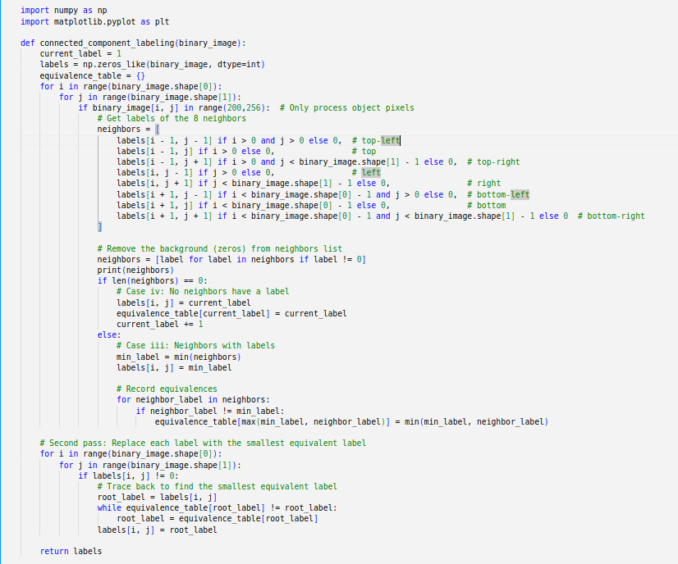

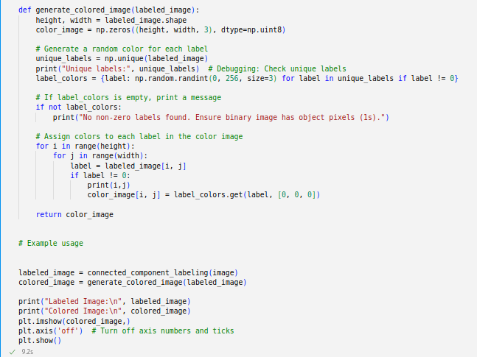

Output:
